**Ideation Phase**

**Brainstorm & Idea Prioritization Template**

|  |  |
| --- | --- |
| **Date** | June 28,2025 |
| **Team ID** | LTVIP2025TMID40347 |
| **Project Name** | Revoluting liver care:Predicting liver cirrhoss using advanced machine learning technique |
| **Maximum Marks** | 4 Marks |

Brainstorming ideas is a creative process where a group generates a list of

potential solutions, suggestions, or concepts for a specific problem or project.

Voting in brainstorming involves participants selecting and prioritizing their

favourite or most promising ideas from the list to determine which ones should

be pursued further.

**Brainstorming for “**

Liver cirrhosis is a chronic and progressive liver disease characterized by the irreversible scarring of liver tissue, which can lead to severe complications and liver failure if left untreated. This project aims to develop a predictive model for the early detection and prognosis of liver cirrhosis using machine learning techniques.The developed predictive model holds promise for early detection and prognosis of liver cirrhosis, enabling healthcare professionals to initiate timely interventions and personalized treatment strategies. By accurately identifying individuals at risk of cirrhosis, this research contributes to improved patient outcomes and the optimization of healthcare resources. Moreover, it highlights the potential of machine learning in the field of hepatology, showcasing its ability to leverage clinical data for predictive modeling and decision support.

**Step-1 : Team Gathering, Collaboration and Select the Problem Statement**

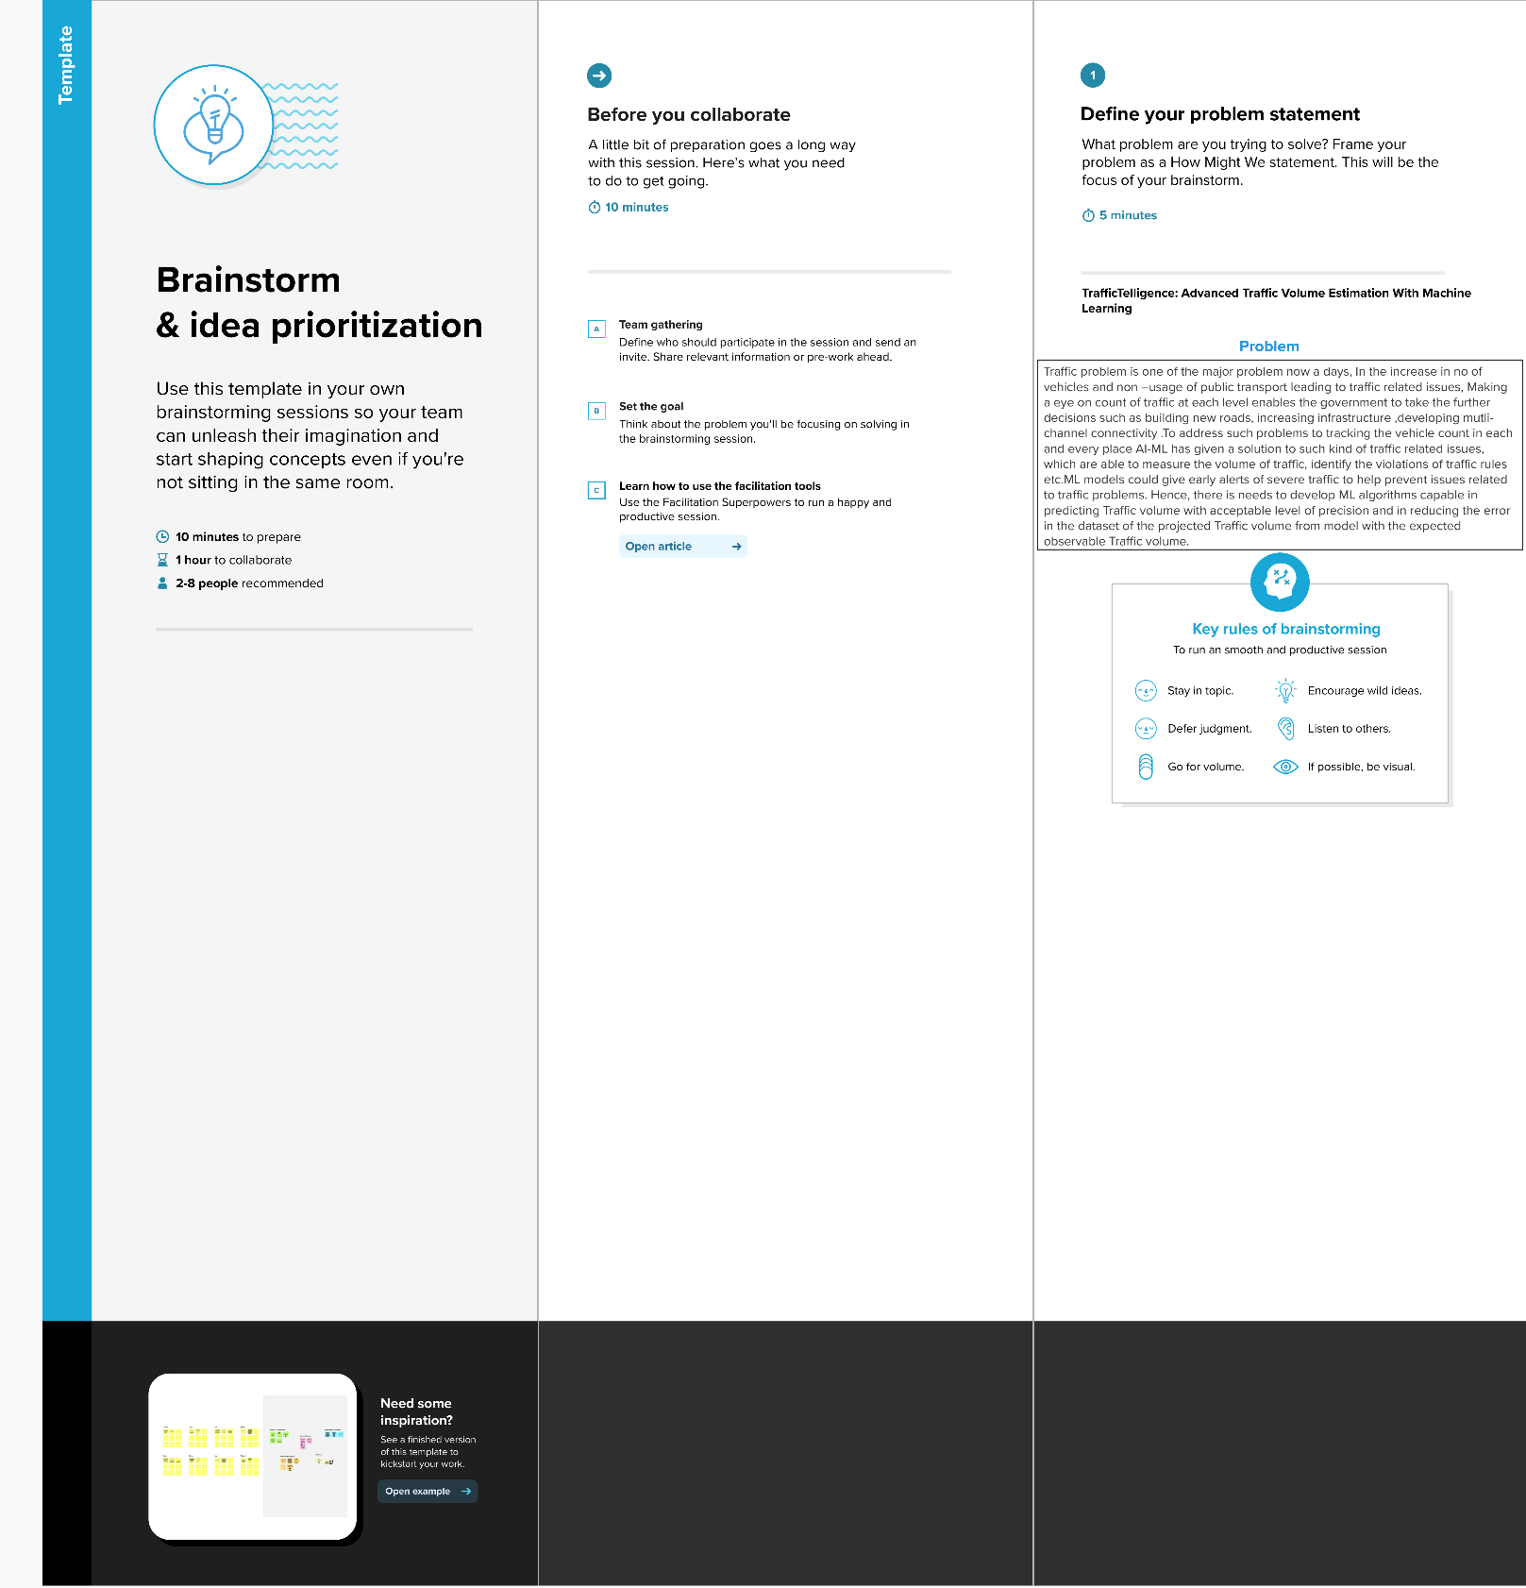

**Step-2: Brainstorm, Idea Listing and grouping**

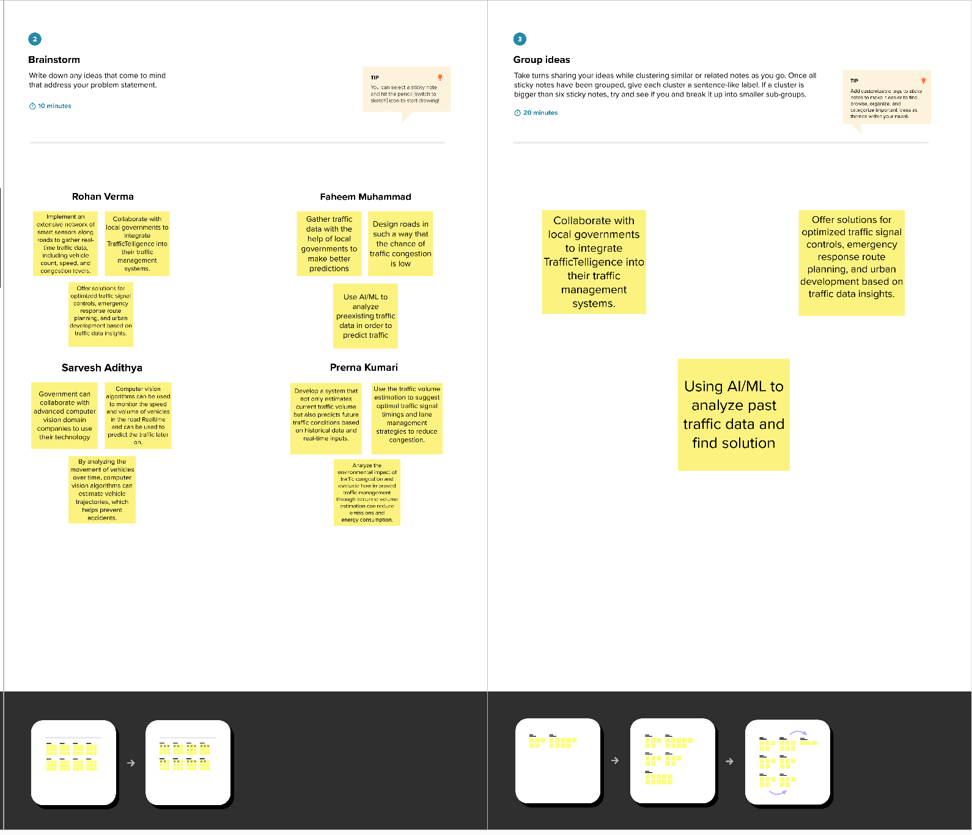

**Step-3: Idea Prioritization**

Idea prioritization is the process of ranking or assessing ideas based on specific criteria such as feasibility, impact, cost, or strategic importance to determine which ideas should be implemented or pursued first.

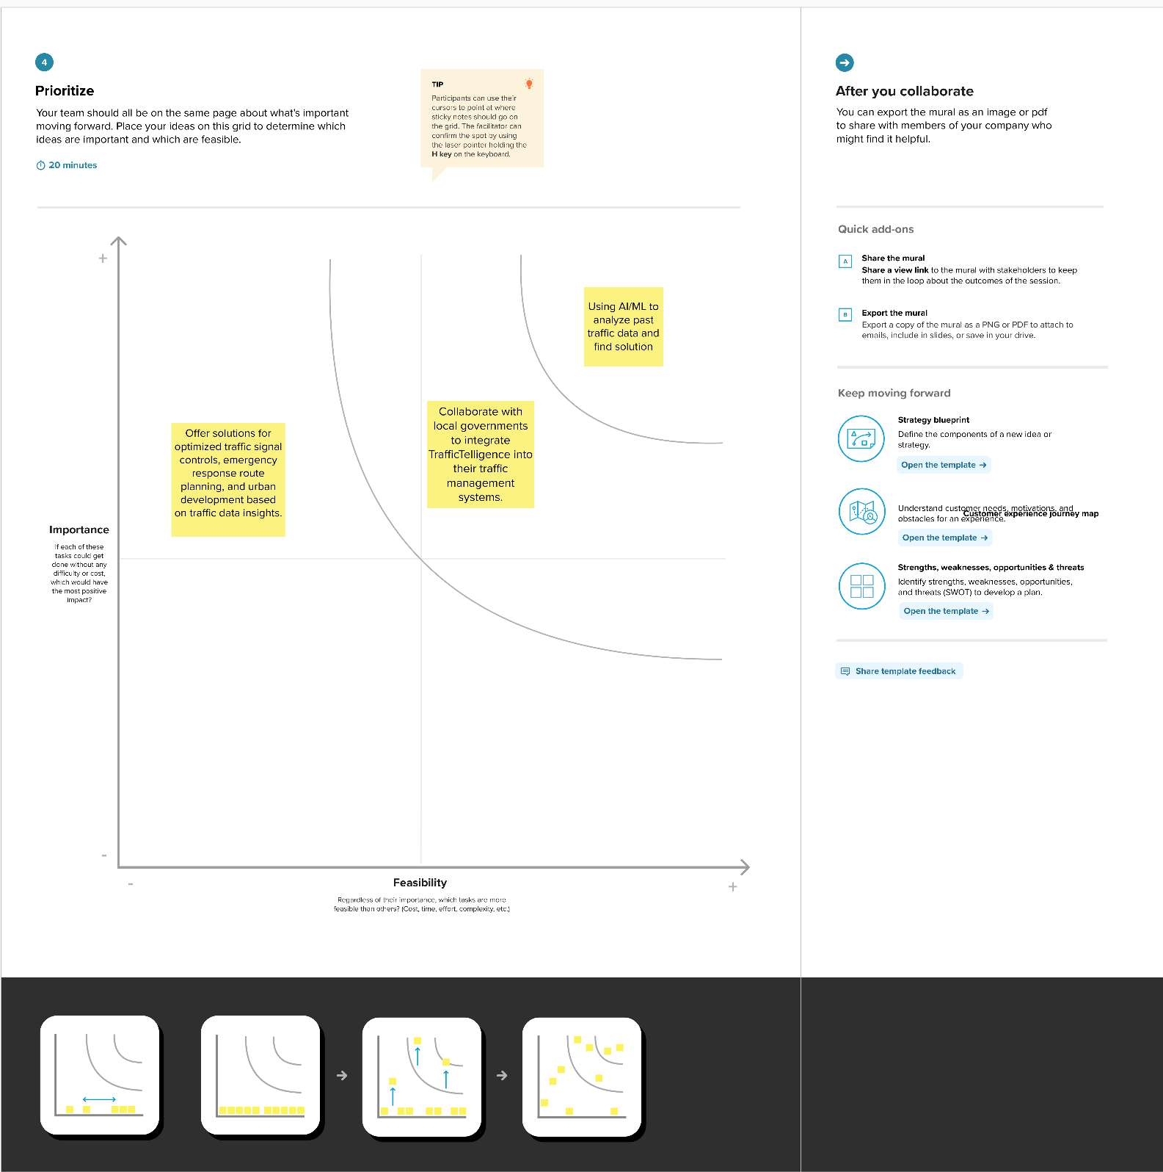

**Here certainly we chose “Using AI/ML to analyze past traffic data and find solution” is:**

Among all of other ideas this was most important to us because, if the model is not accurate enough then the prediction may not be highly accurate. So, this was our most prioritized one.

Then comes our second most important idea such as **“Collaboration with local government to integrate TrafficTelligence into their traffic management systems”**. This was taken as our second because, if we want to give ourself a social responsibility that will be helpful, not only to use but also for others. If we work with other government or organization this might be helpful for a smooth traffic without any problems for Traffic authorities and also for people.

Then comes out our next idea **“Offer solutions for optimized traffic signal controls, emergency response route planning, and urban development based on traffic data insights.”** After fulfilling our main goal, we will scale our ML model not only to predict our main problem but also for extra features such as above-mentioned things. This will give our project more value in all ways.